Resources/Tools

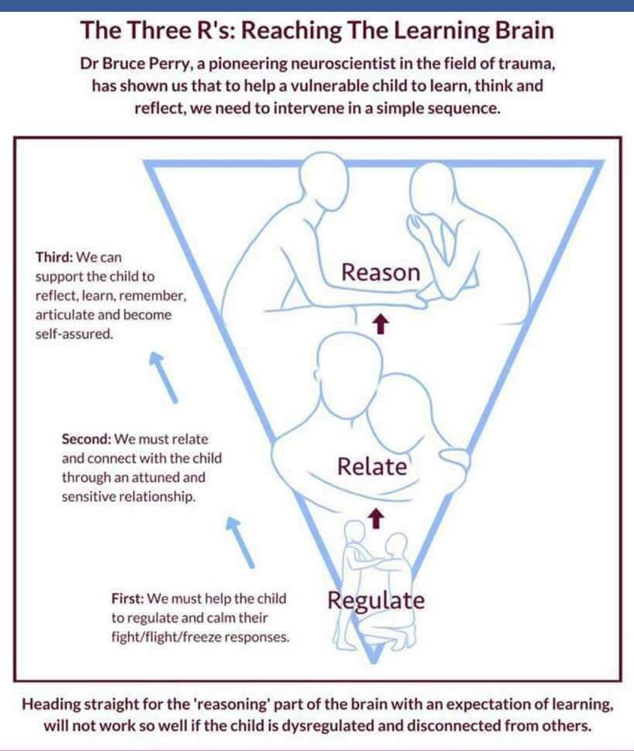

The Moment-to-Moment Assessment: Examples of Questions to Ask to Assess Awareness, Affect, and Action (The 3- A’s)
Source: TST (Saxe, 2007), p. 57
Awareness (consciousness) | Affect (emotion) | Action (behavior)
What were you noticing? | What were you feeling? | What did you do?
Did what you notice seem different? (attention) | Did your feelings change? | Did your behavior change?
Was it harder to pay attention to what was going on around you? (attention) | How strong were the feelings? Were they more intense, less intense, or about the same as before?  Did you feel angrier? | Sometimes kids do things that aren’t very safe when they feel the way you described, such as throwing things or hitting or running away. I’m wondering if you felt like doing these things. What did you do?
What do you remember about what happened? | Did you feel sadder?  Did you feel more scared?
Do you have trouble remembering what happened? (attention) | Did you have less of any of these feelings? | Did you yell or cry or feel like doing those things?
Did it feel like something that happened before was happening again? (orientation) | Sometimes feelings seem really big and strong or really far away or hardly there. Sometimes they are in the middle of those two extremes.  What were your feelings like? | What did people around you do about what you were doing? Did people notice that you seemed different?
How long was this going on? Was it harder to keep track of time? (orientation)  Where did this take place? Did you forget where you were? (orientation) | Was it harder to control any of these feelings?  Did you have trouble feeling anything at all? | Did you feel like hurting yourself? Did you try?  What did you do that made you feel better? What did other people do to make you feel better? What do you think would have helped?
Did it seem like you were back at a time or place of the bad thing that happened to you? (orientation) | Often people have more than one feeling at the same time. Did you have any other feelings? Tell me about those feelings. | Did you use drugs or alcohol?
What did your body feel like? Did your body feel different? (sense of self) |  | Sometimes kid do things sexually when they feel really upset, such as touching other kids in private places or saying sexual things. Do you ever feel like doing those things? Did you do anything like that?
Did it seem like you were younger (or older)? (sense of self) |  | What about eating? Tell me what your eating was like during that time. Did you eat something or get rid of what you ate?
Did you feel like you were a different person? (sense of self)

Examples of Questions to Ask to Assess Awareness, Affect, and Action (the three A’s)
Caregiver’s Version
Awareness (consciousness) | Affect (emotion) | Action (behavior)
What did you notice about the child’s behavior? | What were you feeling? | What did you do?
What was happening before the event? | Angry  Cry  Fear/ Terror | Describe the behavior you observed.
What do you recall about the:  -of day  -location/ room  -people present  Did you notice anything about television, music, a smell in the room (e.g., a perfume, cleaning supplies)? | Helpless  Overwhelmed  Disappointed  Apprehensive | What did you believe this meant?  What has worked in the past?  When have you noticed he is better able to handle these stressors?  (Key: Too hungry, tired, excited. – Changes/ transitions).

Tips for Self-Regulation (Emotional Regulation)- Betterup.com

1. Identify and reduce triggers
You shouldn’t try to avoid negative emotions — or be afraid of them. But you also don’t have to keep putting yourself in a situation that brings on unpleasant emotions. Start to look for patterns or factors that are present when you start to feel strong emotions. This requires some curiosity and honesty. Did something make you feel small? Strong emotions often spring up out of our deep-seated insecurities, especially the ones we hide. What is happening around you and what past experiences does it bring up for you?
When you identify these triggers, you can start to explore why they carry so much weight and whether you can reduce their importance. For example, a CEO might be embarrassed to admit that he gets angry when discussing numbers because he struggled in math class. Understanding this trigger might be enough. Or, the CEO might choose to preview the monthly charts in private to avoid the trigger of feeling like everyone else is waiting for him.
2. Tune into physical symptoms
Pay attention to how you are feeling, including whether you are feeling hungry or tired. These factors can exacerbate your emotions and cause you to interpret your emotions more strongly. If you can address the underlying issue (e.g. hunger, exhaustion), you can change your emotional response. Also look for where you may feel emotion in your body. This can connect to triggers to identify and determine what you may need to do to manage them.
3. Consider the story you are telling yourself
In the absence of information, we fill in the blanks with details of our own. Perhaps you are feeling rejected after you haven’t heard from a family member; you believe it is because they no longer care about you.
Before you make these attributions, ask yourself: what other explanations might be possible? In the example of the family member, what else could be going on with them that would stop them from reaching out to you? Could they be busy or sick? Are they a well-intentioned person who often forgets to follow through on commitments?
BetterUp’s Shonna Waters recommends the “just like me” technique. Whatever motive or action you are assigning to the other person (there’s almost always another person involved), add “just like me” to the end. It is a way of reminding yourself that they are also an imperfect human being.
4. Engage in positive self-talk
When our emotions feel overwhelming, our self-talk can become negative: “I messed up again” or “everyone else is so awful.” If you treat yourself with empathy, you can replace some of this negative talk with positive comments. Try encouraging yourself by saying “I always try so hard” or “People are doing the best they can.” This shift can help mitigate the emotions we’re feeling. You can still be frustrated with a situation that isn’t working but no longer have to assign blame or generalize it beyond the situation.

Got Your ACE Score?

What’s Your ACE Score?
There are 10 types of childhood trauma measured in the ACE Study. Five are personal — physical abuse, verbal abuse, sexual abuse, physical neglect, and emotional neglect. Five are related to other family members: a parent who’s an alcoholic, a mother who’s a victim of domestic violence, a family member in jail, a family member diagnosed with a mental illness, and the disappearance of a parent through divorce, death or abandonment. Each type of trauma counts as one. For example, a person who’s been physically abused, with one alcoholic parent, and a mother who was beaten up has an ACE score of three.
There are, of course, many other types of childhood trauma — racism, bullying, watching a sibling being abused, losing a caregiver (grandmother, mother, grandfather, etc.), homelessness, surviving and recovering from a severe accident, witnessing a father being abused by a mother, witnessing a grandmother abusing a father, involvement with the foster care system, involvement with the juvenile justice system, etc. The ACE Study included only those 10 childhood traumas because those were mentioned as most common by a group of about 300 Kaiser members; those traumas were also well studied individually in the research literature.
The most important thing to remember is that the ACE score is meant as a guideline: If you experienced other types of toxic stress over months or years, then those would likely increase your risk of health consequences.
Prior to your 18th birthday:
- Did a parent or other adult in the household often or very often… Swear at you, insult you, put you down, or humiliate you? or Act in a way that made you afraid that you might be physically hurt?
No___If Yes, enter 1 __
- Did a parent or other adult in the household often or very often… Push, grab, slap, or throw something at you? or Ever hit you so hard that you had marks or were injured?
No___If Yes, enter 1 __
- Did an adult or person at least 5 years older than you ever… Touch or fondle you or have you touch their body in a sexual way? or Attempt or actually have oral, anal, or vaginal intercourse with you?
No___If Yes, enter 1 __
- Did you often or very often feel that … No one in your family loved you or thought you were important or special? or Your family didn’t look out for each other, feel close to each other, or support each other?
No___If Yes, enter 1 __
- Did you often or very often feel that … You didn’t have enough to eat, had to wear dirty clothes, and had no one to protect you? or Your parents were too drunk or high to take care of you or take you to the doctor if you needed it?
No___If Yes, enter 1 __
- Were your parents ever separated or divorced?
No___If Yes, enter 1 __
- Was your mother or stepmother:
Often or very often pushed, grabbed, slapped, or had something thrown at her? or Sometimes, often, or very often kicked, bitten, hit with a fist, or hit with something hard? or Ever repeatedly hit over at least a few minutes or threatened with a gun or knife?
No___If Yes, enter 1 __
- Did you live with anyone who was a problem drinker or alcoholic, or who used street drugs?
No___If Yes, enter 1 __
- Was a household member depressed or mentally ill, or did a household member attempt suicide? No___If Yes, enter 1 __
- Did a household member go to prison?
No___If Yes, enter 1 __
Now add up your “Yes” answers: _ This is your ACE Score
Raising awareness of ACEs can help:
- Change how people think about the causes of ACEs and who could help prevent them.
- Shift the focus from individual responsibility to community solutions.
- Reduce stigma around seeking help with parenting challenges or for substance misuse, depression, or suicidal thoughts.
- Promote safe, stable, nurturing relationships and environments where children live, learn, and play.
Source: ACEs Too High

